Product Inventory Management System

PROJECT OVERVIEW:
The Product Inventory Management System is a backend-focused web application developed using Node.js, Express.js, and MongoDB, designed to provide a secure and scalable solution for managing product data through RESTful APIs. A Product Inventory Management System (PIMS) is a software application designed to track, manage, and organize products in a store or warehouse. It helps businesses maintain accurate records of product stock, monitor inventory levels, and streamline the process of purchasing, storing, and selling goods.
Purpose of the System:
The main goal of the Product Inventory Management System is to:
- Maintain accurate product records
- Track stock availability in real time
- Reduce manual errors in inventory management
- Improve efficiency in stock handling
- Provide reports for better business decision-making
The system enables users to create accounts, log in securely, and access protected routes using JWT-based authentication, ensuring that only authorized users can perform operations. It supports complete CRUD functionality, allowing users to add new products, view their inventory, update product details such as price or quantity, and delete items when needed.
Key Objectives:
• Provide secure JWT-based user authentication and authorization for protected API access.
• Enable efficient product inventory management through RESTful CRUD operations.
• Ensure user-specific data isolation so each user can manage only their own products.
• Implement scalable backend architecture using Node.js, Express.js, and MongoDB.
• Deliver fast and reliable API responses with proper validation and error handling.
Target Users:
• Small business owners managing product stock and inventory records.
• Freelancers or sellers tracking items or services in a structured way.
• Developers learning backend API development and authentication workflows.
• Students working on backend or full-stack development projects.
• Anyone needing a secure and simple backend system for managing product data.
PROJECT INSTRUCTION
• Create backend project folder
• Configure server using Express.js
• Setup MongoDB database connection
• Implement authentication APIs
• Implement product CRUD APIs
• Test APIs using Thunder Client in VS Code
Folder structure example:
inventory-backend
│
├── config
│ └── db.js
├── controllers
├── models
├── routes
├── middleware
├── server.js
├── .env
└── package.json
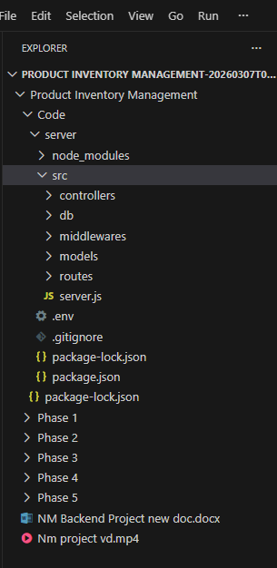
backend now supports:
- User Registration & Login
- JWT Authentication
- Product CRUD operations
- MongoDB Database
- API testing using Thunder Client

PRE-REQUISITES
Software | Purpose
Node.js | JavaScript runtime for backend development
MongoDB | Database storage for users and products
Npm | Package manager for installing dependencies
VS Code | Development environment for writing and testing code

Knowledge Requirements
  - JavaScript ES6 concepts
  - Node.js and Express.js REST API development
  - MongoDB and Mongoose ODM
  - JWT authentication
  - Middleware architecture
PROJECT ARCHITECTURE
The Product Inventory Management System follows a three-tier backend architecture to ensure scalability, maintainability, and clear separation of responsibilities. The architecture divides the system into three main layers: Presentation Layer, Application Layer, and Data Layer.
1. Presentation Layer (Client Layer)
The presentation layer represents the interface through which users interact with the system. This layer is responsible for collecting user input and displaying the processed results returned by the backend server.
In this project, API requests are tested using the Thunder Client extension inside Visual Studio Code. The client sends HTTP requests such as GET, POST, PUT, and DELETE to the backend server.
Responsibilities:
- Sending API requests to the server
- Receiving responses from the server
- Displaying product or authentication data
2. Application Layer (Backend / Server Layer)
The application layer contains the business logic of the system. It processes requests received from the client, performs necessary operations, and communicates with the database.
The backend server is built using Express.js running on Node.js.
This layer includes several modules such as:
- Authentication Module – Handles user registration and login using JWT tokens.
- Product Management Module – Performs CRUD operations (Create, Read, Update, Delete) for products.
- Middleware – Handles request validation, authentication, and error handling.
Responsibilities:
- Handling API requests
- Implementing business logic
- Managing authentication and authorization
- Communicating with the database
3. Data Layer (Database Layer)
The data layer manages the storage and retrieval of application data. All product and user information is stored in a NoSQL database.
In this project, the database used is MongoDB, and database interactions are handled using Mongoose.
Responsibilities:
- Storing product data
- Storing user authentication details
- Performing database queries and updates
- Three-Tier Architecture Diagram (Conceptual)
- Presentation Layer
(Thunder Client / Frontend)
│
│ HTTP Requests
▼
Application Layer
(Node.js + Express.js Server)
│
│ Database Queries
▼
Data Layer
MongoDB
.
Node.js + Express Backend
  - RESTful API architecture
  - JWT authentication middleware
  - MVC pattern (Models, Controllers, Routes)
  - Input validation and error handling
  - MongoDB Database
  - Document-based NoSQL storage
  - Mongoose ODM for schema modeling
  - Two collections: Users and Contacts
Database Architecture (MongoDB)
The Product Inventory Management System uses MongoDB as the primary database for storing application data. MongoDB is a document-based database that stores data in JSON-like documents, making it flexible and suitable for modern web applications. 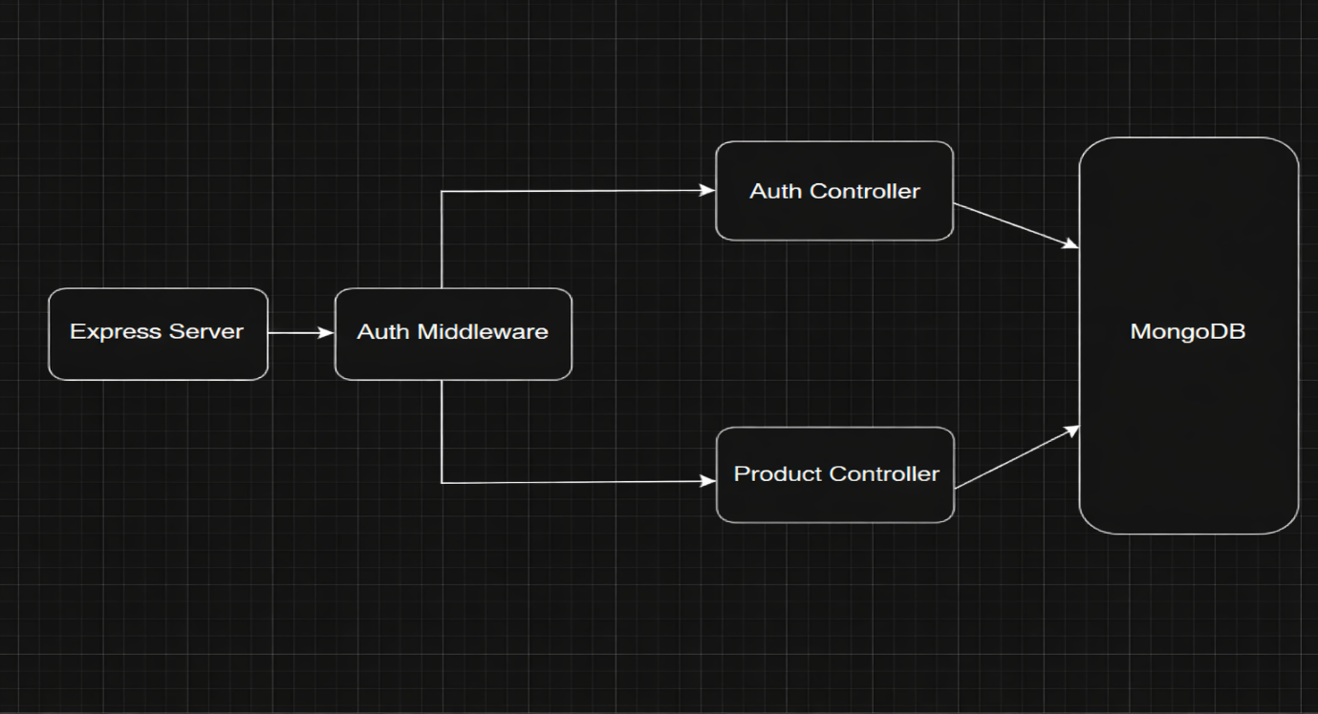
To interact with the database from the backend application, the project uses Mongoose, which provides schema-based data modeling and simplifies database operations in Node.js applications.
The database is structured into two main collections: Users and Products.
• Indexed fields for optimized queries
Users Collection:
The Users collection stores information related to registered users of the system. Each document represents a single user.
Fields in Users Collection:
• _id – Unique identifier automatically generated by MongoDB
• name – Name of the user
• email – User's email address (used for login)
• password – Encrypted password stored using hashing for security
• timestamps – Automatically stores creation and update time of the record
Products Collection:
The Products collection stores details about the products managed in the inventory system.

Fields in Products Collection:
- _id – Unique identifier for each product
- userId – Reference ID of the user who created or owns the product
- name – Name of the product
- price – Price of the product
- quantity – Available stock quantity
- description – Additional information about the product
- timestamps – Automatically records creation and update time
Relationship: In the Product Inventory Management System, the relationship between Users and Products follows a One-to-Many relationship.
This means that one user can create and manage multiple products, but each product is associated with only one specific user. This relationship is implemented by storing the userId field in the Products collection, which references the _id field of the user in the Users collection.
One User → Many Products

ER Diagram
The Entity–Relationship (ER) Diagram represents the structure of the database and shows how different entities in the system are related to each other. In the Product Inventory Management System, the main entities are User and Product.
The system follows a One-to-Many relationship, where one user can manage multiple products, while each product belongs to only one user.
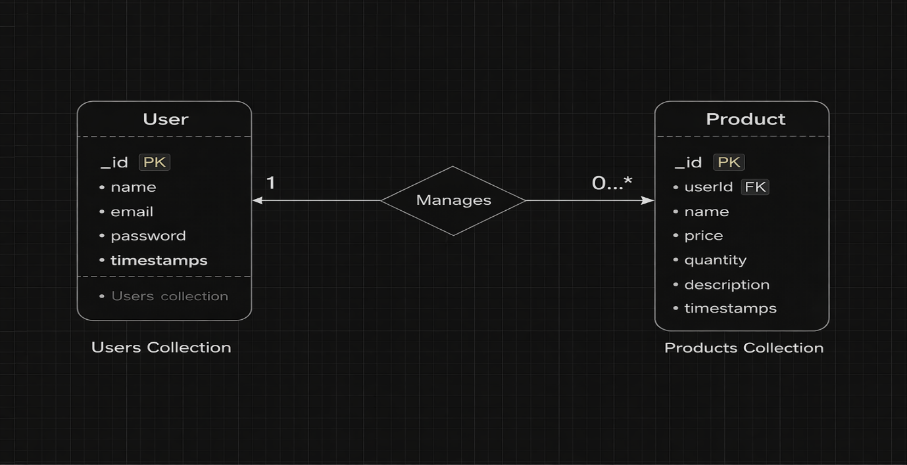

ER diagram showing User → Product relationship:
Features:
Core Features
S.No | Feature | Description
1 | User Authentication | JWT-based register and login system
2 | Product CRUD | Add, view, update and delete products
3 | Private Data Access | Users access only their own products
4 | Product Search | Search products by name
5 | Secure API | Middleware protected routes

Roles and Responsibility
In the Product Inventory Management System, the main role in the system is the User. The user interacts with the system to manage product inventory, including creating, updating, deleting, and searching products. The system ensures that only registered and authenticated users can perform these operations.
User
The User is responsible for managing products in the inventory system. The user must first create an account and log in to access the system features.
1. Registration
Users can register in the system by providing basic information such as name, email, and password. During registration, the system stores the user details securely in the database and encrypts the password for security.
2. Login
After registration, users can log in to the system using their registered email and password. Once authenticated, the system provides access to product management functionalities.
3. Add Product
Users can add new products to the inventory by entering details such as:
- Product name
- Price
- Quantity
- Description
The product information is then stored in the database and associated with the logged-in user.
4. Edit Product
Users can update the details of an existing product. For example, they can modify the product price, quantity, or description whenever changes are required.
5. Delete Product
Users can remove products from the inventory when they are no longer needed or available. This operation deletes the product record from the database.
6. Search Product
Users can search for products using a keyword or product name. This feature helps users quickly find specific products in the inventory.
BACKEND DEVOPLEMENT
Setup Express Server: 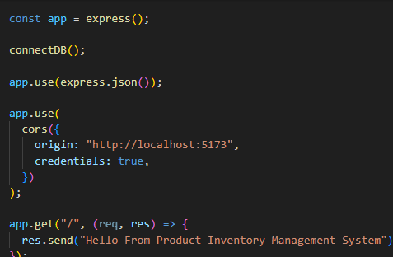
Inside src/server.js, create the basic Express server.
Create Controllers
Inside: src/controllers/
Create:
auth.controller.js
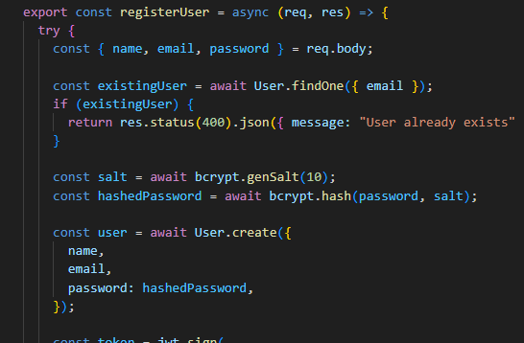
Main Functionalities:
- Register User: Creates a new user account after validating email uniqueness and encrypting the password.
- Login User: Verifies credentials and returns a JWT token for protected API access.
product.controller.js
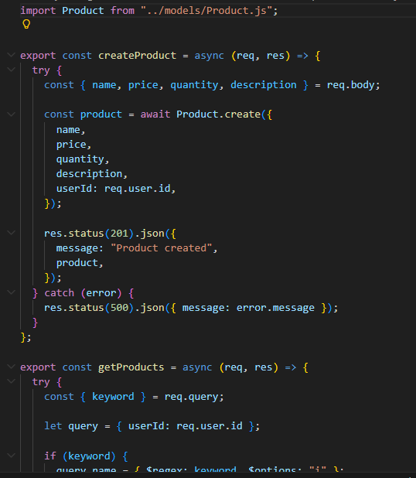
Main Functionalities:
- Register User: Creates a new user account after validating email uniqueness and encrypting the password.Login User: Verifies credentials and returns a JWT token for protected API access.
Auth Middleware (protect)
The Auth Middleware secures protected routes by verifying the JSON Web Token (JWT) sent in the request header. It checks for a valid Authorization header starting with "Bearer " and validates the token using the secret key. If the token is valid, the decoded user information is attached to req.user and the request proceeds to the next controller. If the token is missing or invalid, the middleware returns a 401 Unauthorized response, preventing access to private APIs.
Create Routes
Inside: src/routes/

Create:

auth.routes.js
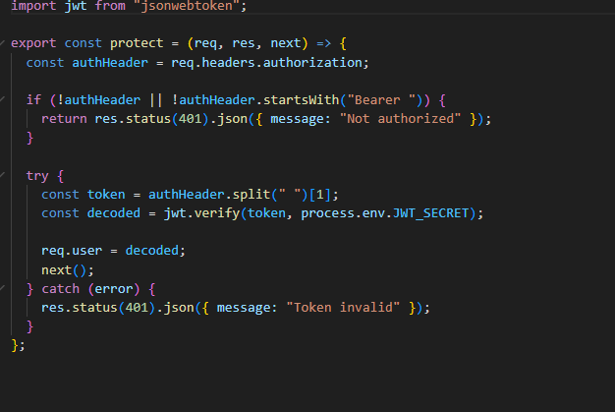
Create Routes
Inside: src/routes/
Create:
auth.routes.js
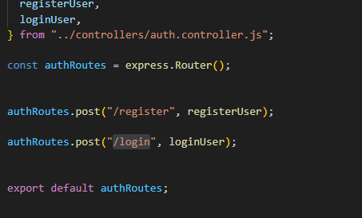
product.routes.js
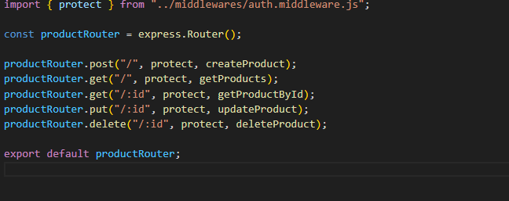

Connect Routes to Server
Import all routes into server.js
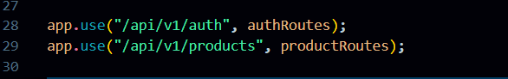
Database Configuration and Setup:
Database configuration and setup is the process of creating and connecting a database to the backend application. It includes creating a MongoDB Atlas cluster, adding the database connection string to the .env file, and establishing a connection using Mongoose in src/db/db.js so the backend can interact with the database before API testing.
Create Models:
Inside src/models/ create:
- User.js
- Product.js
User Model:
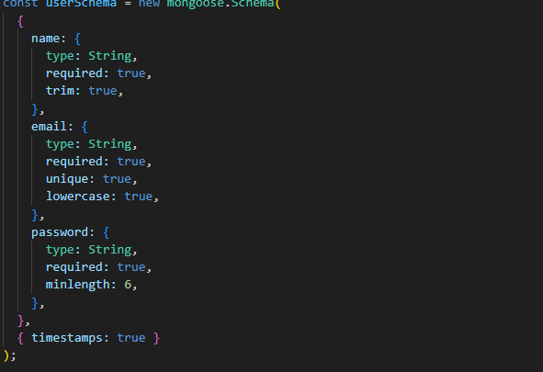
Product Model:
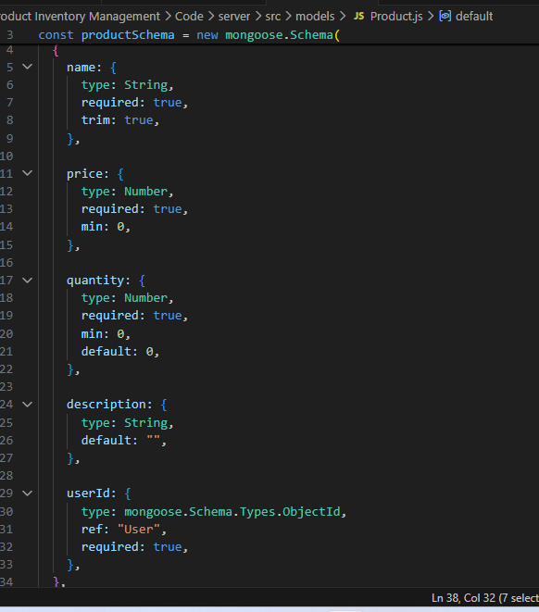
API Testing with Thunder Client
Thunder Client is a lightweight VS Code extension for testing APIs.
Steps:
- Install Thunder Client from the VS Code extensions.
- Open Thunder Client and create a new request.
- Test the APIs using the following endpoints:
- Product APIs (Protected)
- Include the Authorization header:
Authorization: Bearer <JWT_TOKEN>
Method | Endpoint | Description
POST | /api/v1/products | Create a new product
GET | /api/v1/products | Get all products of the user
PUT | /api/v1/products/:id | Update product by ID
DELETE | /api/v1/products/:id | Delete product by ID
Register User:
The Register functionality enables new users to create an account in the Product Inventory Management System. It ensures that user data is validated, secure, and unique before granting access to the system.
1️⃣ Endpoint
Method | Endpoint |  | Description | Access
POST | /api/v1/auth/register |  | Register a new user | Public
2️⃣ Request Payload
Users must submit the following details in JSON format:
{
"name": "John Doe",
"email": "john@example.com",
"password": "password123"
}
Field Requirements:
- name – Required, string
- email – Required, string, must be unique
- password – Required, string, will be hashed before storing
3️⃣ Functionality Flow
- Receive Request
- The server receives the registration request at /api/v1/auth/register.
- Validate Input
- Checks that all required fields are provided.
- Validates the email format and ensures it is unique in the database.
- Hash Password
- Uses bcrypt to securely hash the password before storing it.
- Create User
- Saves the user in the MongoDB Users collection.
- Send Response
- Returns a success message if registration is successful.
- Returns an error message if validation fails or email already exists.
4️⃣ Example Response
Success:
{
"message": "User registered successfully"
}
Error (Email already exists):
{
"message": "User already exists"
}
Error (Missing fields):
{
"message": "All fields are required"
}
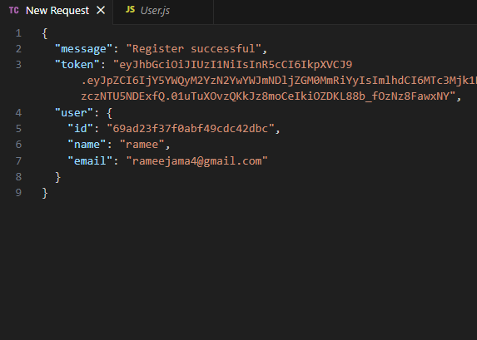

5️⃣ Security Measures
- Passwords are hashed before storing, preventing plain-text storage.
- Email uniqueness is enforced to avoid duplicate accounts.
- Validation ensures only properly formatted data is accepted.
Login User:
The Login functionality allows registered users to access the Product Inventory Management System by verifying their credentials and generating a JWT token for secure API access.
1️.Endpoint

Method | Endpoint | Description | Access
POST | /api/v1/auth/login | Authenticate user and return JWT | Public
2️.Request Payload
Users submit their login credentials in JSON format:
{
"email": "john@example.com",
"password": "password123"
}
Field Requirements:
- email – Required, string
- password – Required, string
3️.Functionality Flow
- Receive Request
- The server receives a POST request at /api/v1/auth/login.
- Validate Input
- Checks that email and password are provided.
- Verify User
- Searches the Users collection for the provided email.
- Returns an error if the user does not exist.
- Compare Password
- Uses bcrypt.compare() to match the entered password with the stored hashed password.
- Returns an error if the password is invalid.
- Generate JWT Token
- On successful authentication, generates a JWT token using the secret key from .env.
- The token includes the user’s ID and optionally an expiry time.
- Send Response
- Returns the JWT token for accessing protected routes.
Example Response
Success:
{
"token": "eyJhbGciOiJIUzI1NiIsInR5cCI6IkpXVCJ9..."
}
Error (User not found):
{
"message": "User not found"
}
Error (Invalid password):
{
"message": "Invalid credentials"
}
Error (Missing fields):
{
"message": "All fields are required"
}
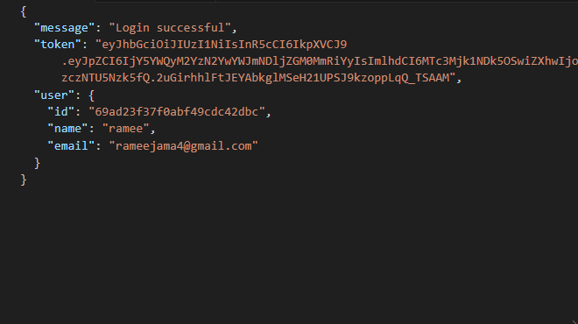
5️⃣ Security Measures
- Passwords are never stored in plain text; only hashed passwords are compared.
- Tokens are signed with a secret key to prevent tampering.
- Tokens are required for accessing protected product routes, ensuring secure access.
Create product:
The Product Controller manages all inventory-related actions. Each operation is JWT-protected, ensuring only the product owner can access or modify their data.
1️⃣ Create Product
Endpoint: POST /api/v1/products
Access: Private (JWT required)
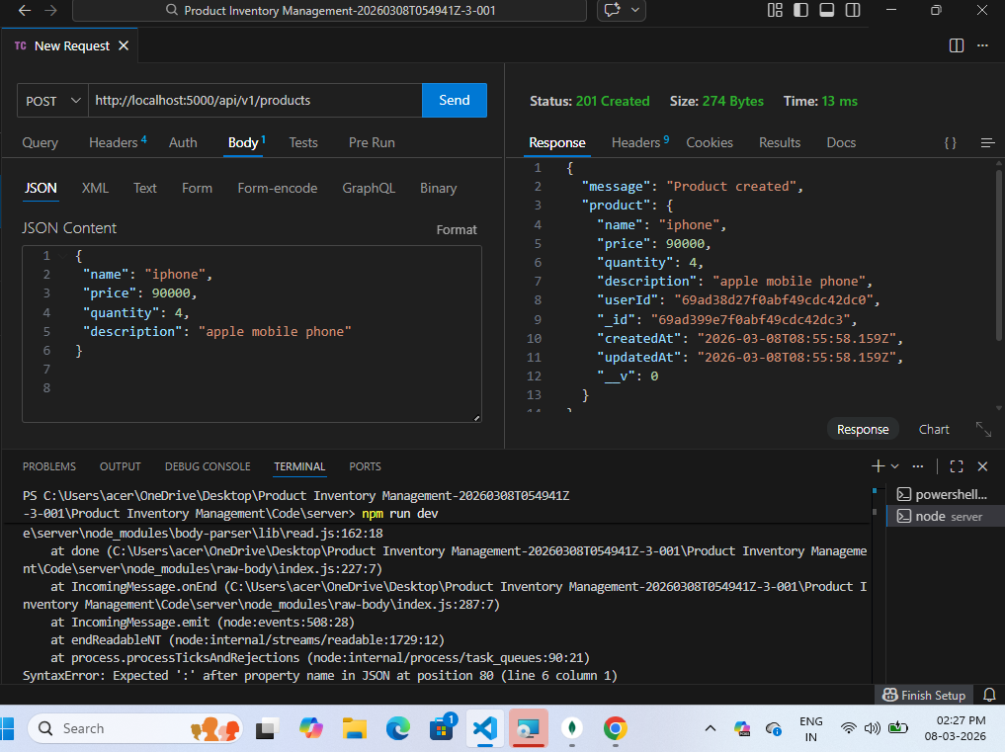
Functionality:
- Authenticated users can add a new product by submitting details: name, price, quantity, and description.
- The system automatically links the product to the userId of the logged-in user.

2️⃣ Get All Products
Endpoint: GET /api/v1/products
Access: Private
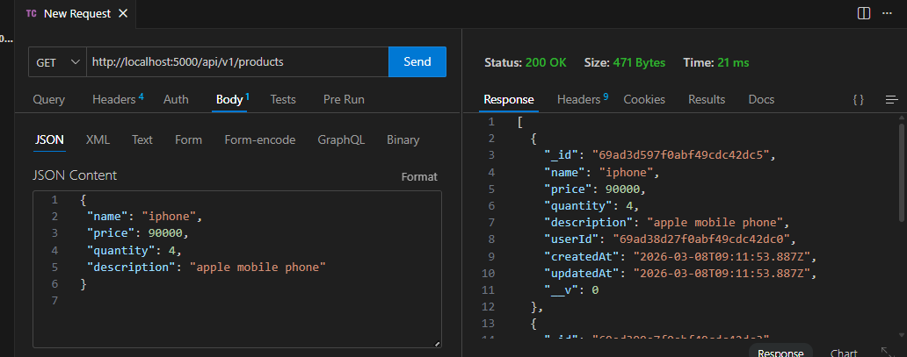
Functionality:
- Fetches all products belonging to the authenticated user.
- Ensures data privacy so users see only their own inventory.

3️⃣ Update Product
Endpoint: PUT /api/v1/products/:id
Access: Private
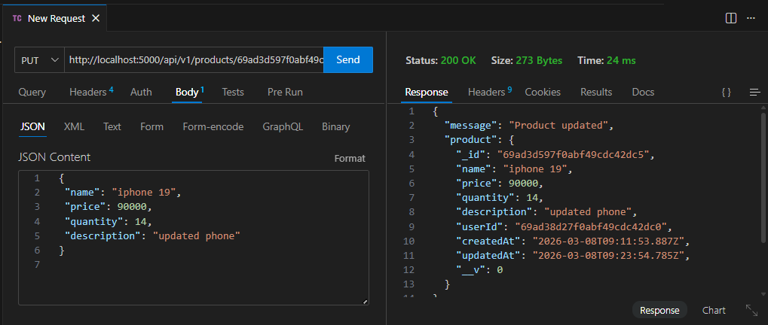

Functionality:
- Allows the owner to modify product details: name, price, quantity, description.
- Verifies ownership via userId before updating
4️⃣ Delete Product
Endpoint: DELETE /api/v1/products/:id
Access: Private
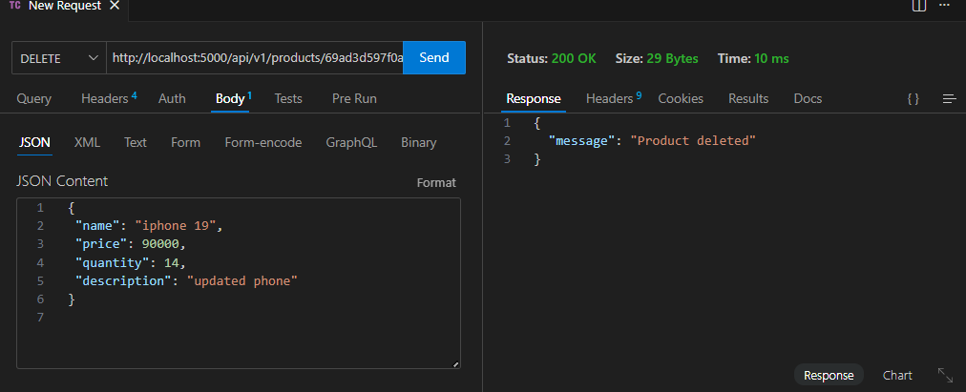

Functionality:
- Allows the owner to permanently remove a product from their inventory.
- Verifies ownership via userId before deletion.
Key Points:
- All product operations are protected using the Auth Middleware.
- Each product is linked to a userId, maintaining private ownership.
- Supports full CRUD functionality for inventory management.
Project Demo Video: https://drive.google.com/file/d/1IgcvDhLlL2EAbADj49bozTaEbbpy-gMT/view?usp=sharing

